VIT BHOPAL UNIVERSITY
School of Computing Science and Engineering
Kothri Kalan, Sehore, Madhya Pradesh – 466114
A PROJECT REPORT ON
NOUGHTS AND CROSSES GAME
(Tic-Tac-Toe using Python)
Submitted in partial fulfilment of the requirements of the course
Problem Solving using Python | B.Tech First Year
Submitted by
Detail | Information
Student Name | Hemik Nayankumar Patel
Registration No. | 26BCE11303
Branch | CSE
Course Faculty | Dr. Nirmala E
Academic Year | 2026 – 2027

CERTIFICATE
This is to certify that the project report entitled “Noughts and Crosses Game (Tic-Tac-Toe using Python)” is a bonafide work carried out by Hemik Nayankumar Patel, Registration No. 26BCE11303, a first-year B.Tech student of VIT Bhopal University, during the academic year 2026–2027, under my guidance and supervision.
The work embodied in this report is original and has not been submitted elsewhere for the award of any degree, diploma or certificate.

Date: ____________
Place: Bhopal
_______________________
Signature of Faculty Guide

DECLARATION
I, Hemik Nayankumar Patel, hereby declare that the project report titled “Noughts and Crosses Game (Tic-Tac-Toe using Python)” submitted to VIT Bhopal University is a record of original work done by me. The code was written and tested by me, and all sources of help and reference have been duly acknowledged.

_______________________
Hemik Nayankumar Patel
Reg. No.: 26BCE11303

ACKNOWLEDGEMENT
I would like to express my sincere gratitude to my course faculty, Dr. Nirmala E, for their constant guidance, encouragement and valuable suggestions throughout this project. Their explanations of Python fundamentals made it possible for me to turn a simple idea into a working program.
I am also thankful to VIT Bhopal University for providing the laboratory facilities and learning environment needed to complete this work. Finally, I thank my friends and family for their support and for playing the game with me during testing.

ABSTRACT
This project presents a console-based implementation of the classic two-player game Noughts and Crosses (also known as Tic-Tac-Toe) using the Python programming language. The game is played on a 3×3 grid in which two players, X and O, take alternate turns to mark an empty cell. The first player to place three of their marks in a horizontal, vertical or diagonal line wins the game.
The program uses a list to store the state of the board, functions to organise the logic, tuples to define the eight winning combinations, and loops and conditional statements to control the flow of the game. It validates player input so that a player cannot choose an occupied cell or a number outside the range 1 to 9. The messages are written in a friendly Hinglish style to make the game more engaging for Indian users.
The project demonstrates the practical use of core Python concepts such as lists, functions, loops, conditionals, f-strings and input handling, and serves as a foundation for building larger games and applications.
Keywords: Python, Tic-Tac-Toe, Noughts and Crosses, Console Game, Lists, Functions.

TABLE OF CONTENTS
1. Introduction
2. Objectives of the Project
3. Tools and Technologies Used
4. System Design and Algorithm
5. Source Code
6. Code Explanation
7. Sample Output
8. Testing and Test Cases
9. Limitations and Future Scope
10. Conclusion
11. References

1. INTRODUCTION

1.1 Background
Noughts and Crosses is one of the oldest and most popular paper-and-pencil games in the world. It is simple enough for a child to learn in a minute, yet it introduces important ideas such as turn-taking, state tracking and decision making. These same ideas appear in almost every game and interactive application, which makes Tic-Tac-Toe an ideal first project for a beginner programmer.

1.2 Problem Statement
To design and develop a two-player Noughts and Crosses game in Python that runs in the console, displays the board after every move, validates user input, detects a winning condition automatically and informs the players of the result.

1.3 Scope
The project covers a local two-player game played on the same computer. It does not include a graphical interface, network play or a computer opponent; these are discussed as future enhancements.

2. OBJECTIVES OF THE PROJECT
- To apply the basic concepts of Python programming learnt in the first-year course in a complete working program.
- To represent the game board using a list and display it in a clear 3×3 grid format.
- To implement modular code using user-defined functions.
- To detect all eight possible winning combinations automatically.
- To validate user input and handle invalid or repeated moves gracefully.
- To make the game friendly and interactive through Hinglish messages.

3. TOOLS AND TECHNOLOGIES USED
Component | Description
Programming Language | Python 3.x
Editor / IDE | IDLE / VS Code / PyCharm (any Python editor)
Operating System | Windows / Linux / macOS
Hardware | Any computer with minimum 2 GB RAM
Libraries | None (only built-in functions such as print, input and int)

3.1 Python Concepts Used
- List and list comprehension – to create and store the board.
- Functions (def) – grid(), chanceofwin() and play().
- Tuples – to store each winning combination of positions.
- for and while loops – to check winning lines and to run the game turns.
- if–else conditions – to validate moves and switch players.
- f-strings – to display the board and player messages.
- Type conversion – int() to convert user input to a number.

4. SYSTEM DESIGN AND ALGORITHM

4.1 Board Representation
The board is stored in a list named box containing nine strings, initially “1” to “9”. Index 0 to 8 of the list corresponds to positions 1 to 9 on the board, as shown below.
1 (index 0) | 2 (index 1) | 3 (index 2)
4 (index 3) | 5 (index 4) | 6 (index 5)
7 (index 6) | 8 (index 7) | 9 (index 8)

4.2 Winning Combinations
There are eight ways to win: three rows, three columns and two diagonals. Using list indices these are: (0,1,2), (3,4,5), (6,7,8), (0,3,6), (1,4,7), (2,5,8), (0,4,8) and (2,4,6).

4.3 Algorithm
Start the program and display the welcome message.
Create the board list with values 1 to 9 and display the empty grid.
Set the current player to X and the number of turns played to 0.
Repeat while turns are less than 9:
a) Ask the current player to choose a position from 1 to 9.
b) Convert the input to an integer and subtract 1 to get the list index.
c) If the index is outside 0 to 8, display an error message.
d) If the cell already contains X or O, display an “already filled” message.
e) Otherwise place the player’s symbol on the board, increase the turn count and display the grid.
f) Check all eight winning combinations. If any matches, declare the current player the winner and stop.
g) Switch the player (X to O or O to X).
If nine turns are completed without a winner, the game ends.

4.4 Function Overview
Function | Purpose
grid() | Prints the current state of the 3×3 board with separators.
chanceofwin(p1) | Checks whether player p1 has three matching marks in any winning combination; returns True or False.
play() | Main game loop: handles input, validation, turn switching and win detection.

5. SOURCE CODE
The complete Python source code of the project is given below.
print("Aaka Swagat Hai Noughts and Crosses Game Me!")
print("Yeh lo, kaunsa block kahan hai:")
box=[str(i) for i in range (1,10)]
def grid():
print(f"\n {box[0]} | {box[1]} | {box[2]} " )
print("-----|-----|-----")
print(f" {box[3]} | {box[4]} | {box[5]} " )
print("-----|-----|-----")
print(f" {box[6]} | {box[7]} | {box[8]}\n " )
def chanceofwin(p1):
c1=[(0,1,2),(3,4,5),(6,7,8),(0,3,6),(1,4,7),(2,5,8),(0,4,8),(2,4,6)]
for a,b,c in c1:
if box[a]==box[b]==box[c]==p1:
return True
return False
def play():
p="X"
turns=0
grid()
while turns<9:
m1=input(f"Player {p}, Choose position (1-9):")
m2=int(m1)-1
if m2>=0 and m2<=8:
if box[m2]!="X" and box[m2]!="O":
box[m2]=p
turns=turns+1
grid()
if chanceofwin(p):
print(f"Player {p} Jeeta Hai 7 Crore Rs!")
return
if p=="X":
p="O"
else:
p="X"
else:
print("Yeh position already fill ho chuki hai. Kripya kisi aur vacant block ke liye apply karein.")
else:
print("Arey bhai, board ke bahar kahan ja rahe ho? 1 se 9 ke andar hi number choose karo!")
print("Dono Player Samman Haii!")
play()

6. CODE EXPLANATION

6.1 Welcome Message and Board Creation
The first two print() statements greet the players. The statement box=[str(i) for i in range(1,10)] uses list comprehension to create the list ['1','2',...,'9']. Numbers are stored as strings so that they can later be replaced by “X” or “O” in the same list.

6.2 The grid() Function
This function prints the board using f-strings. Each row shows three values of the list separated by vertical bars, and horizontal dashed lines separate the rows. It is called at the start and after every valid move so that players always see the latest board.

6.3 The chanceofwin() Function
The list c1 contains eight tuples, each holding three indices that form a winning line. The for loop unpacks each tuple into a, b and c and checks whether box[a], box[b] and box[c] are all equal to the player’s symbol using a chained comparison. If any line matches, the function returns True; otherwise it returns False after all lines are checked.

6.4 The play() Function
The variable p stores the current player (starting with X) and turns counts the moves made. Inside the while loop the program reads the position, converts it to an index and performs two checks: first that the index lies between 0 and 8, and second that the cell is not already occupied. If both checks pass, the symbol is placed on the board, the turn counter is increased and the grid is displayed. The program then calls chanceofwin(); if it returns True, the winner is announced and the function ends using return. If there is no winner, the player is switched so that the other player moves next.

6.5 Error Handling Messages
If the player selects an occupied cell or a number outside the range 1–9, a Hinglish error message is displayed and the same player is asked to try again because the turn counter and the current player are not changed.

7. SAMPLE OUTPUT

7.1 Game Start

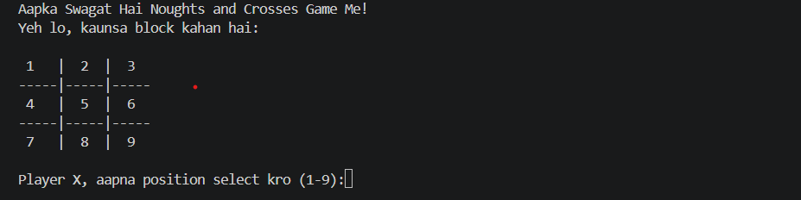

7.2 After First Move

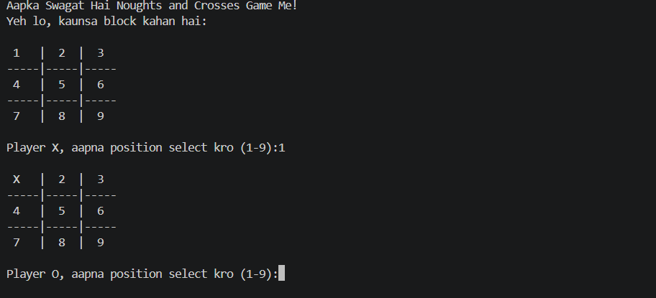

7.3.1 Invalid Move (Occupied Cell)

7.3.2 Invalid Move (Out of range)

7.4 Winning Result

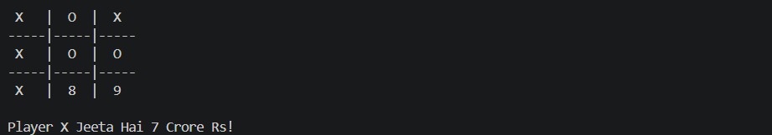

8. TESTING AND TEST CASES
The program was tested with different inputs to verify that each feature works correctly.
No. | Test Input | Expected Result | Status
1 | Valid position (e.g., 5) | Symbol placed and board updated | Pass
2 | Already occupied position | “Already filled” message shown; same player retries | Pass
3 | Number 0 or 10 or above | “Out of board” message shown | Pass
4 | Three X in a row | Player X declared winner | Pass
5 | Three O in a diagonal | Player O declared winner | Pass
6 | Non-numeric input (e.g., “a”) | Program should show an error message | Fails – program stops with ValueError (see Limitations)

9. LIMITATIONS AND FUTURE SCOPE

9.1 Limitations
- If the user types a letter or leaves the input empty, int() raises a ValueError and the program stops.
- When all nine cells are filled with no winner, the program simply ends without announcing a draw.
- The game is text-based and supports only two human players on the same computer.
- The message “Dono Player Samman Haii!” is printed after every turn, including after a winning-free valid move, which may look repetitive.

9.2 Future Scope
- Add try–except to handle non-numeric input without crashing.
- Add an explicit “Match Draw” message when all turns are used.
- Add an option to play again and to keep a scoreboard.
- Develop a single-player mode with a computer opponent using random moves or the Minimax algorithm.
- Create a graphical version using Tkinter or Pygame.
- Extend the game to larger boards such as 4×4 or 5×5.

10. CONCLUSION
The Noughts and Crosses game was successfully implemented in Python. The program correctly displays the board, accepts moves from two players, prevents illegal moves, switches turns and detects all eight winning combinations. Through this project, the fundamental concepts of lists, functions, loops, conditional statements and string formatting were applied in a practical way.
The project also highlighted the importance of input validation and testing, and identified areas such as exception handling and draw detection that can be improved. Overall, it has strengthened my logic building and problem-solving skills and provides a solid base for developing more advanced Python applications in the coming semesters.

11. REFERENCES
- Python Software Foundation, “Python 3 Documentation,” https://docs.python.org/3/
- Eric Matthes, Python Crash Course, 3rd Edition, No Starch Press.
- Al Sweigart, Automate the Boring Stuff with Python, 2nd Edition, No Starch Press.
- W3Schools, “Python Tutorial,” https://www.w3schools.com/python/
- GeeksforGeeks, “Python Programming Language,” https://www.geeksforgeeks.org/python-programming-language/
- Course lecture notes, VIT Bhopal University.

